# MALWA INSTITUTE OF SCIENCE & TECHNOLOGY,

**INDORE**



# * Voice ChatBot*

# Minor Project Report

**Submitted To Submitted By**

# Mr. Siddharth Jain Priya Ojha

# Mrs .Prerita Kulkarni Yash Sharma

# 

**DECLARATION**

Student of MALWA INSTITUTE OF SCIENCE AND

TECNOLOGY INDORE, hereby declare that the work done by us to do the Minor Project titled “**The Voice ChatBot**” is authenticate as per my knowledge and work outcome of my own research. This report in any form has not been submitted to any other institute or university for any degree or similar award.

# Date :- 02/06/2024 Priya Ojha

**Place :- Indore Yash Sharma**

# B.tech (CS) - 3rd year

**ACKNOWLEDGEMENT**

A Minor Project is an important milestone in the completion of any Professional Course. As a student of B.tech (Full Time)

– 6th SEM I got golden opportunity to do the Project work. It gives me immense pleasure to express my feelings of deep gratitude towards the subject teacher without the support of whom it would have been very difficult to accomplish this project. In is Respect, I am extremely fortunate in having **Asst. Professor Mrs. Prerita Kulkarni** as my project Guide on this Project work. I thank for his valuable guidance, supervision & encouragement during course of this work.

I would like to thank my principal **Dr. K.K. Gupta** for his encouragement during the course of this work and for his moral support during this study.

I would be failing in my duty if I don’t thank my parents, who have remained a constant source of inspiration throughout. At last I would like to thank all those who have helped to provide direction, information and advice at all stages in this Project Work.

# Date:-02/06/2024 B.tech(CS) 3rd year

**CERTIFICATE**

This is to certify that Priya Ojha and Yash Sharma student of B.tech [CS] – 3rd year of Malwa Institute of Science & Technology, Indore has completed Minor Project work on **THE VOICE CHATBOT** and has submitted a report for the same within in partial fulfillment of requirement of the course by Rajiv Gandhi Proudyogiki Vishwavidyalaya, Bhopal for the year 2021-2025. During the period of his/her dissertation with us he/she had been exposed to different process we found punctual, hardworking and inquisitive.

We wish him/her all the best for future endeavors.

# Signature: Signature:

**Siddharth Jain Dr. K. K. Gupta**

# (HOD) Principal

**TABLE OF CONTENTS**

|  |  |  |
| --- | --- | --- |
| **S.No.** | **Content** | **Page No.** |
| 1. | Introduction | 1-2 |
| 2. | Abstract | 3-4 |
| 3. | Objective and future vision | 4 |
| 4. | Development Me tools and technology | 5 |
| 5. | Future Metools and technology | 6 |
| 6. | Other implementations | 7 |
| 7. | Our implementations | 8-10 |
| 8. | Conclusion | 11 |

# INTRODUCTION

**Voice Chatbot**

A chatbot is a software or computer program that simulates human conversation or chatter through text or voice interactions. Users in both business-to-consumer (B2C) and business-to-business (B2B) environments increasingly use chatbot virtual assistants to handle simple tasks.

Adding chatbot assistants reduces overhead costs, better utilizes support staff time and enables organizations to provide customer service around the clock.

Chatbots range from simplistic models that operate off of scripts to provide quick responses to specific questions, to artificial intelligence ([AI](https://www.techtarget.com/searchenterpriseai/definition/AI-Artificial-Intelligence)) and machine learning ([ML](https://www.techtarget.com/whatis/definition/machine-learning-algorithm)) models that can converse with users and complete more complex tasks. Chatbots also simulate human conversation in either written or spoken form.

## Why are chatbots important?

Organizations looking to increase sales or service productivity might adopt chatbots for time savings and efficiency, as [AI chatbots can converse with users](https://www.techtarget.com/searchcustomerexperience/feature/10-examples-of-AI-in-customer-service) and answer recurring questions. These services are also typically available 24/7.

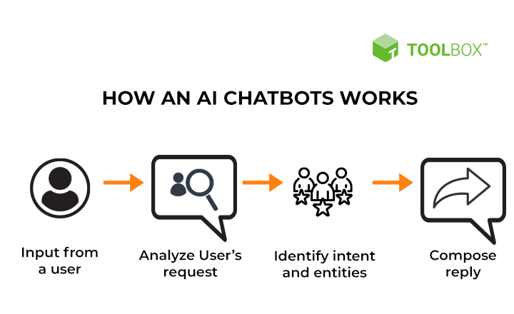

# ABSTRACT

The concept and implementation of a voice recognition chat bot for customer assistance is presented in this paper. Chat bots are automated tools that aid in the replication of human behaviour in a dialogue. They also aid humans in a discussion or when they have a question about something on the internet.

A Chat-bot is a software application used to conduct an online chat conversation via text or text-to- speech, instead of providing direct contact with a live human agent. Designed to convincingly simulate the way a human would behave as a conversational partner.

## Voice assistants are software agents that can interpret human speech and respond via synthesized voices.

Chatbots, or conversational interfaces as they are also known, present a new way for individuals to interact with computer systems. Traditionally, to get a question answered by a software program involved using a search engine, or filling out a form. A chatbot allows a user to simply ask questions in the same manner that they would address a human. The most well known chatbots currently are voice chatbots: Alexa and Siri. However, chatbots are currently being adopted at a high rate on computer chat platforms

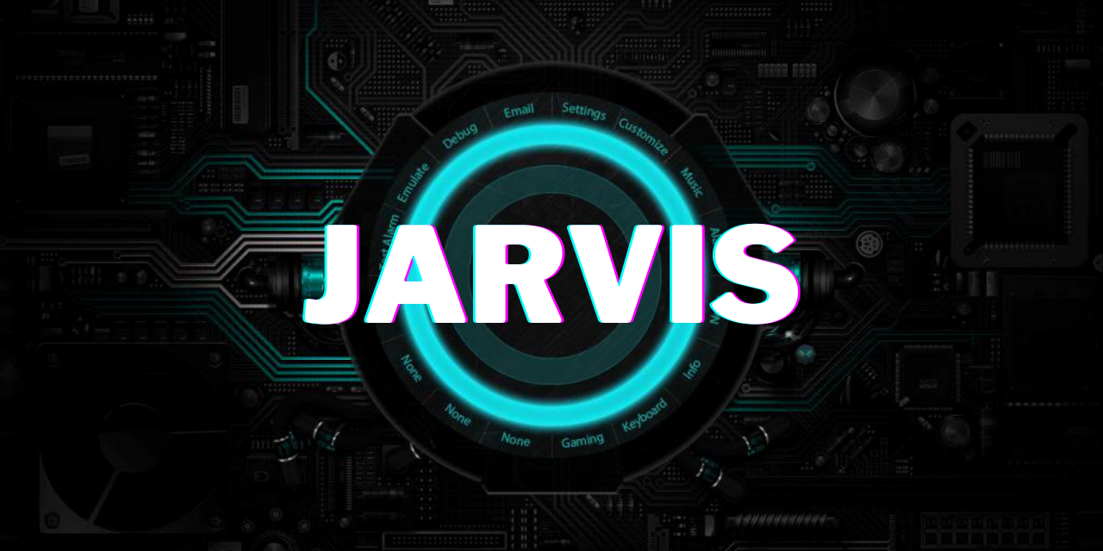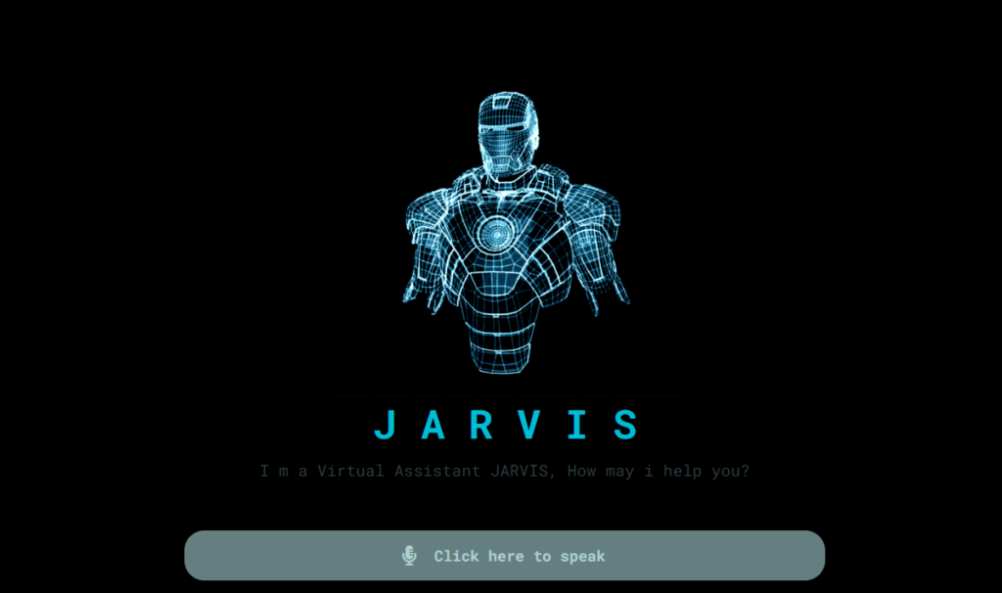

# Objective and future vision

* Our objective to provide an engaging platform for individuals of all ages and interests to challenge themselves and expand their knowledge through interactive quizzes.
* Languages that will be used to develop QUIZTIME are HTML, CSS, JAVA SCRIPT.
* To accommodate future additions, resources can also be allocated/allocated in advance.
* Now, for the future, we will insist on adding User Login and data base so that user can also check their Past Scores any time.

# DEVELOPMENT METOOLS AND TECHNOLOGY

* In This paper we will develop an Online Quiz system for free self-practice and for fun so user can judge their own performance and capability of mind.
* We will be using visual studio to write code for develop quiz- system.
* Language structure including, sharp code fulfillment, pieces, code refactoring, and implanted Git also we have used some scripting languages to develop system including PHP,HTML,CSS, Java script etc.
* PHP code can be perfectly embedded into HTML (Hypertext markup language) basically HTML is known as markup language, annals additionally as we want to make it user interface so we breaking point and its grant is freed from cost and CSS represents Cascading Style Sheets.
* When an administrators first opened the framework, He is diverted to the primary page. From that point, he can play out his interests.

# FUTURE METOOLS AND TECHNOLOGY

* User will be able to Sign-in into the framework or website in order have a private profile of best scores.
* MySQL data base we have used in this project to store the data entries, Results, user, questions and types of questions.
* The administrator can Update own Profile, and furthermore see all that which is accessible at administrator board.
* At the point when a client is first signed into the framework, He is diverted on the principle page. From that point, he can rehearse for Quizzes to pass judgment on their own performance.
* In our quiz system we have focused only multiple-choice question based exam, it can be further improved with some additional features like desertion written questions, students can invite more friends.

# OTHER IMPLIMENTATIONS

|  |  |  |
| --- | --- | --- |
| * Design of Online Quiz System for   Practice. | * Kapeel Dev, Rajesh   Kumar, Imran saeed, Farooq Iqbal. | * developed an Online Quiz   system for free self-practice  so students can judge their  own performance before sit  in professional online exam. |
|  |  | * The ‘MCQ Quiz |
| * A Project on Online MCQ Quiz   Application. | * Hamayoon Behmanush Ph.D.   Student at Saarland University. | Application’  project developed to  overcome the time consuming problem of |
|  |  | manual system. |

**OUR IMPLIMENTATIONS**

* First of all our framework is easy to use website framework.
* We are intended to add RANK SYSTEM in our site.
* User can compete with other user in order to get higher rank.
* Also we are going to make user login system to store scores.
* We will be making a very attractive framework.

# INDEX HTML

* This is the very first phase of code in our website.
* Which is intended to make a front page for the Quiz.
* This is the opening page where user can chose a quiz according to the interest.

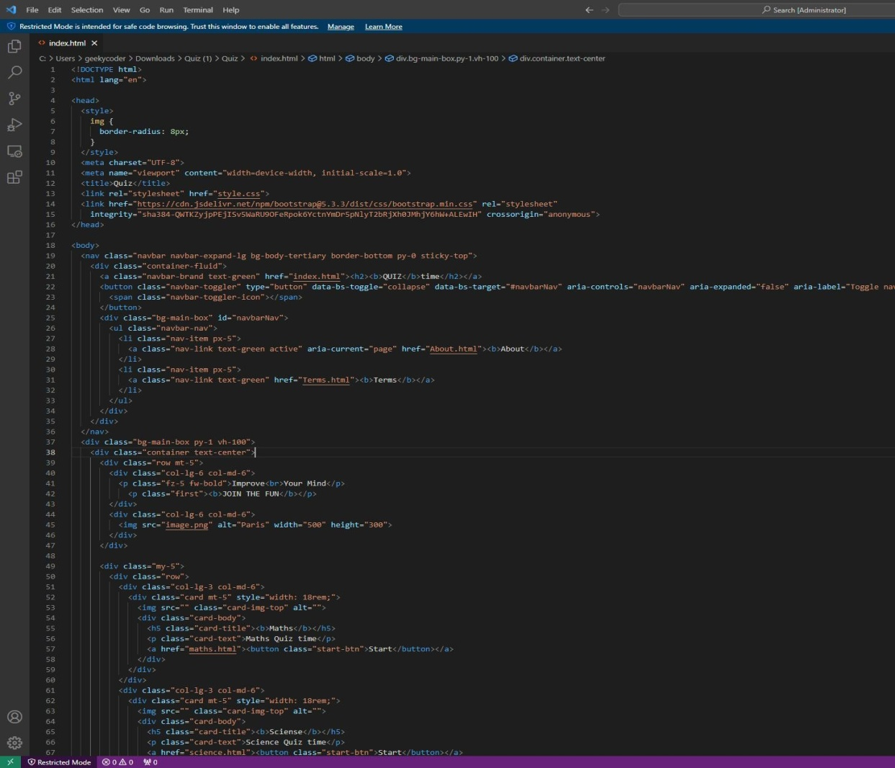

# INDEX SQL

* "At Quiz-time, we rely on SQL to ensure the secure and efficient storage of all our quiz data. This includes questions, answers, user information, and quiz results. MySQL's powerful querying capabilities allow us to swiftly retrieve and manage this data, keeping Quiz-time running smoothly."
* SQL empowers us to personalize the quiz experience for each user. By analyzing user data and quiz history, we can tailor recommendations, suggest relevant quizzes, and track progress. This professionalization keeps users engaged and motivated to explore more.

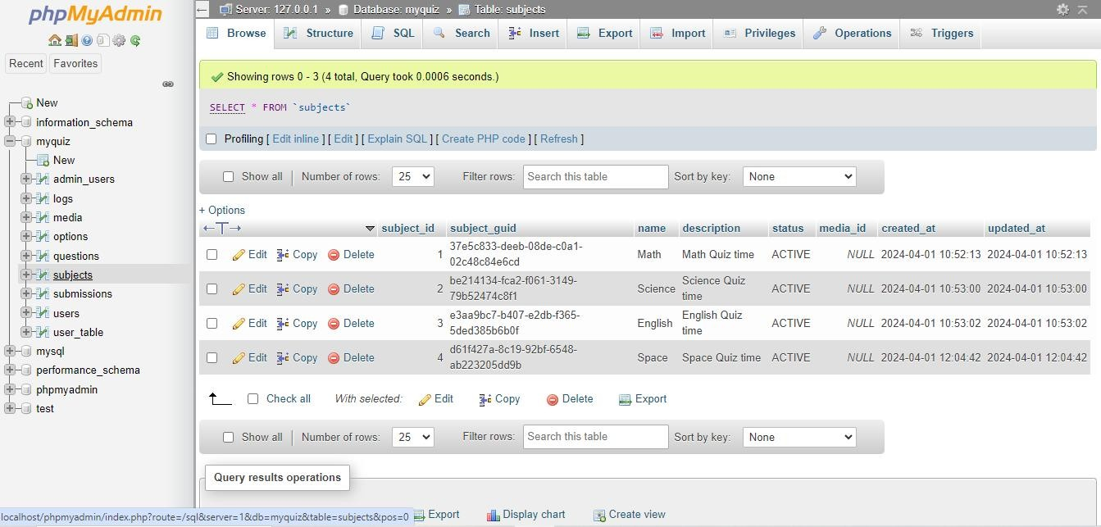

# Conclusion

* Dive deeper, ignite your mind, and embark on a world of engaging quizzes!
* Our website is Coming soon, but your journey of learning, fun, and self discovery can begin today!
* Thank you everyone for giving your valuable time and showing interest.